Class Assignment 08

Complete the class work and attach the screenshots/images at the end.

## Experimental Data: Constructing a Sequential Circuit using T Flip-Flops

|  |  |  |  |  |  |  |  |
| --- | --- | --- | --- | --- | --- | --- | --- |
| **Present state** | | **Input** | **Next state** | | **Output** | **Flip-flop input functions** | |
| **A** | **B** | **X** | **A** | **B** | **Y** | **TA** | **TB** |
| 0 | 0 | 0 | 0 | 1 | 0 | 0 | 1 |
| 0 | 0 | 1 | 1 | 0 | 1 | 1 | 0 |
| 0 | 1 | 0 | 0 | 1 | 0 | 0 | 0 |
| 0 | 1 | 1 | 1 | 0 | 1 | 1 | 1 |
| 1 | 0 | 0 | 1 | 0 | 0 | 0 | 0 |
| 1 | 0 | 1 | 0 | 0 | 0 | 1 | 0 |
| 1 | 1 | 0 | X | X | X | X | X |
| 1 | 1 | 1 | X | X | X | X | X |

**Table F.2.1:** State Table for circuit using T Flip-Flops

|  |  |  |  |
| --- | --- | --- | --- |
| 0 | 1 | 1 | 0 |
| 0 | 1 | X | X |

|  |  |  |  |
| --- | --- | --- | --- |
| 1 | 0 | 1 | 0 |
| 0 | 0 | X | X |

|  |  |  |  |
| --- | --- | --- | --- |
| 0 | 1 | 1 | 0 |
| 0 | 0 | X | X |

**TA = X TB =A’B’X’+BX Y = A’X**

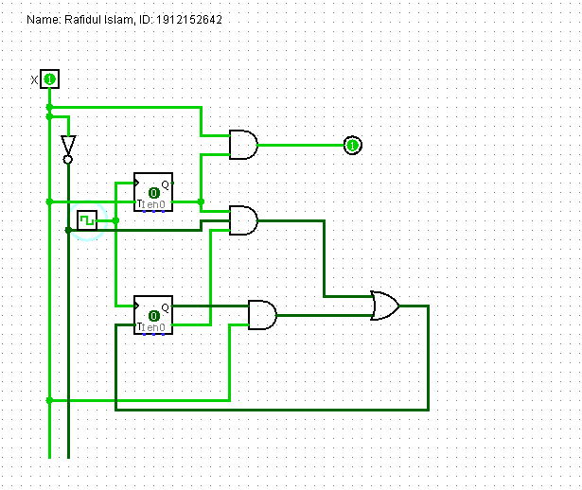

**Figure F.2.1:** Circuit Diagram

## Experimental Data: Constructing a Sequential Circuit using D Flip-Flops

|  |  |  |  |  |  |  |  |
| --- | --- | --- | --- | --- | --- | --- | --- |
| **Present state** | | **Input** | **Next state** | | **Output** | **Flip-flop input functions** | |
| **A** | **B** | **X** | **A** | **B** | **Y** | **DA** | **DB** |
| 0 | 0 | 0 | 1 | 1 | 0 | 1 | 1 |
| 0 | 0 | 1 | 0 | 1 | 0 | 0 | 1 |
| 0 | 1 | 0 | 1 | 1 | 0 | 1 | 1 |
| 0 | 1 | 1 | 0 | 0 | 0 | 0 | 0 |
| 1 | 0 | 0 | 1 | 0 | 0 | 1 | 0 |
| 1 | 0 | 1 | 1 | 1 | 1 | 1 | 1 |
| 1 | 1 | 0 | 1 | 0 | 0 | 1 | 0 |
| 1 | 1 | 1 | 1 | 0 | 1 | 1 | 0 |

**Table F.3.1:** State Table for circuit using D Flip-Flops

|  |  |  |  |
| --- | --- | --- | --- |
| 1 | 0 | 0 | 1 |
| 1 | 1 | 1 | 1 |

|  |  |  |  |
| --- | --- | --- | --- |
| 1 | 1 | 0 | 1 |
| 0 | 1 | 0 | 0 |

|  |  |  |  |
| --- | --- | --- | --- |
| 0 | 0 | 0 | 0 |
| 0 | 1 | 1 | 0 |

**DA = x’+A DB = A’x’+B’x Y = Ax**

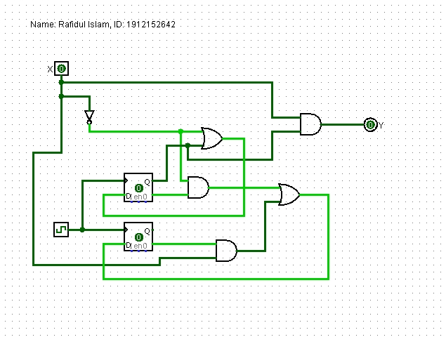

**Figure F.3.1:** Circuit Diagram

9